SZABIST University Internship Survey Form
*Required
- Company Name *

_______________________________________________________________________________

- Address *

_______________________________________________________________________________
_______________________________________________________________________________

- Name *

_______________________________________________________________________________

- Designation *

_______________________________________________________________________________

- Industry/ Sector *

_______________________________________________________________________________

This part of the survey pertains to student from Mechatronics Department, who have completed his/her internship at your esteemed organization. The purpose is to obtain employers’ input on the quality of education SZABIST is providing and to assess the Program Learning Outcomes attainment of Mechatronics Engineering program. We seek your help in completing this survey. Please evaluate this student intern on the following items by checking the appropriate rating.

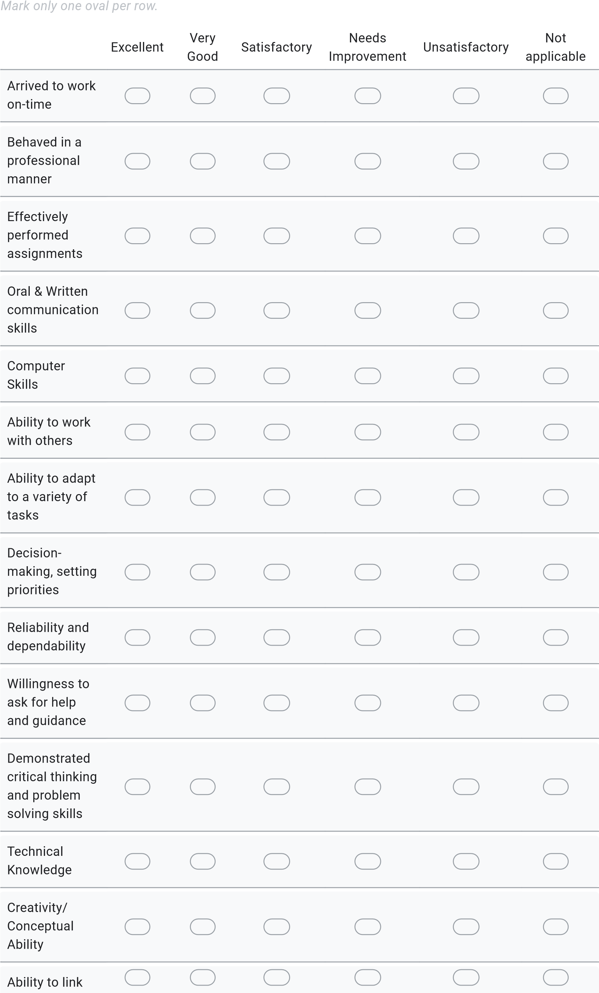

theory to
practice
Making and
meeting
deadlines
Seemed
interested and
in; and
enthusiastic
about the
internship
experience
Resource Requirements
This part of the survey pertains to gauge resource requirement at your Organization, this will help us to improve your organization’s experience with SZABIST.

- In which month does your organization finalize its annual human resource needs? *
_______________________________________________________________________________
- How many fresh graduates are you planning to hire in 2023? *
Mark only one oval.
1-5
6-10
11-15
Other: _______________________________________________________________________________

SZABIST University
Related Questions

- Which on-campus activities (other than recruitment) would your organization like to conduct at SZABIST University? *
______________________________________________________________________________
______________________________________________________________________________

10. Please rate your organization’s experience with Student Career Services and Alumni Relations department? *
Mark only one oval.
Very Good
Good
Average
Poor
Very Poor
- Do you have suggestion(s) for improving your organization’s experience with SZABIST University?*
______________________________________________________________________________
______________________________________________________________________________

